NodeJS Server

NodeJS Version 4.7.0
OS - CentOS7 64 bit
NodeJS version 4 installation on CentOS 7:

Step 1: Perform the following command to install Java for Elasticsearch

yum install java-1.8.0-openjdk.x86_64

Step 2: Perform the following commands to install NodeJS 4.7.0

curl -sL https://rpm.nodesource.com/setup_4.x | bash -

yum -y install nodejs

Step 3: To compile and install native addons from npm you may also need to install build tools:

yum install gcc-c++ make

Step 4: Then, We have to install the Log-stash software for NodeJS. In order to install the logstash, we have to create a repo file. Perform the following command for create a repo file.

sudo vi /etc/yum.repos.d/logstash.repo

Step 5: Paste the following contents on to the repo file and save.

[logstash-2.2]
name=logstash repository for 2.2 packages
baseurl=http://packages.elasticsearch.org/logstash/2.2/centos
gpgcheck=1
gpgkey=http://packages.elasticsearch.org/GPG-KEY-elasticsearch
enabled=1

Please find the following image for reference.
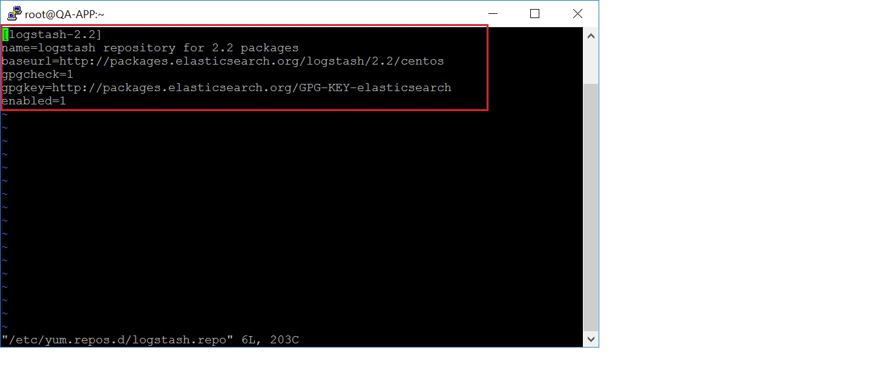

To start the backend server we need to upload the zipped source code (HouseMD.zip) into /root/serverCode/ (directory path).

The zipped source code will be given by Development team.

We need to unzip the source code in to the same directory directory

We need to move the

Step 6: Then finally, perform the following command to install logstash
sudo yum -y install logstash

After installing the logstash we need to create 3 configuration files for logstash in the following path.
(/etc/logstash/conf.d)

- First file name: 01-input.conf

perform the following command to create the file.

vi /etc/logstash/conf.d/01-input.conf

Editor will open after perform the above command,
Then, We need to paste the following code in to that editor

Our NodeJS server path is (/root/serverCode/) if you want to maintain the source in different directory you have to modify the server path directory in the following code and replace it with the current server path.

input {
file {
path => "/root/serverCode/doctor.json"
start_position => beginning
codec => json
}
file {
path => "/root/serverCode/appointmentsAndLeaves.json"
start_position => beginning
codec => json
}
file {
path => "/root/serverCode/doctorAddress.json"
start_position => beginning
codec => json
}
file {
path => "/root/serverCode/deleteDoctorAddress.json"
start_position => beginning
codec => json
}
file {
path => "/root/serverCode/updatedDoctorAddress.json"
start_position => beginning
codec => json
}
}

(After paste the above command, click Esc+:wq! To save the file and exit.)

Please find the below image for reference.
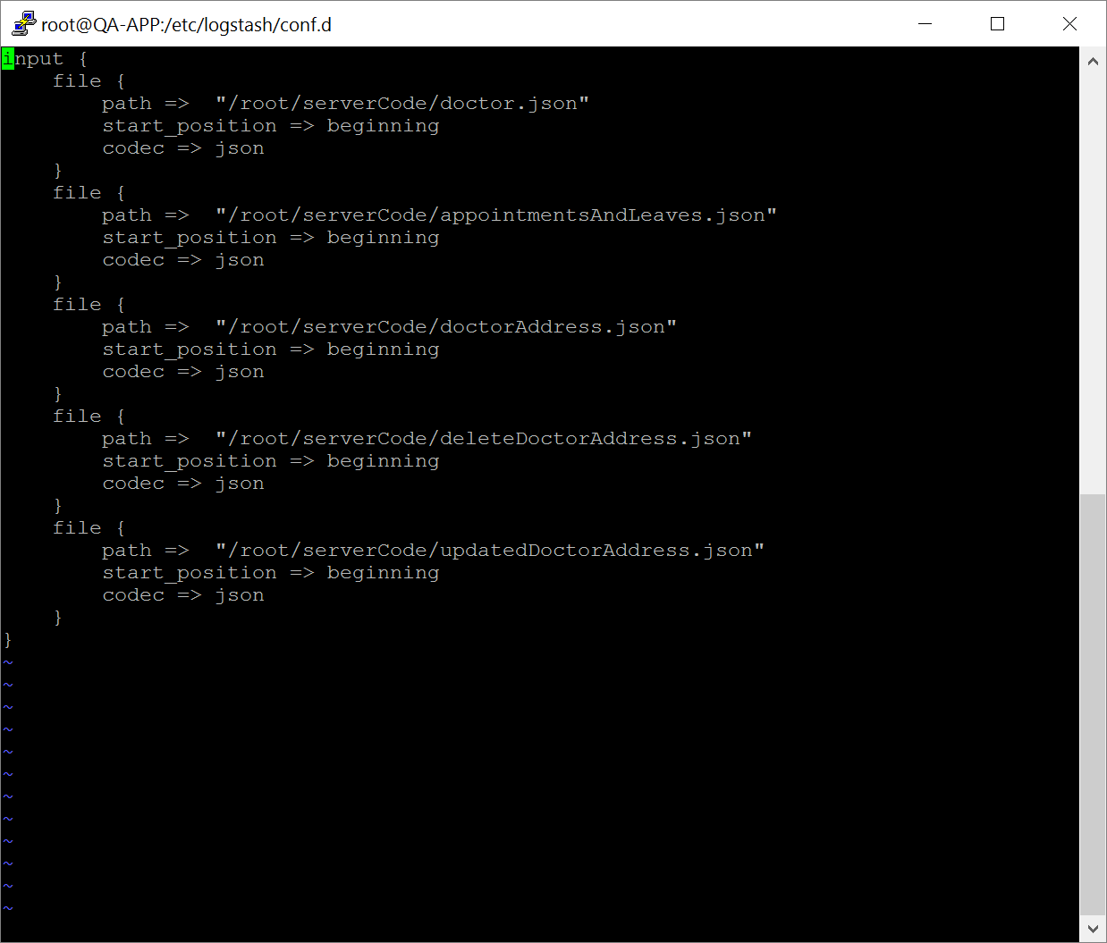

- First file name: 20-filter.conf

perform the following command to create the file.

vi /etc/logstash/conf.d/20-filter.conf

Editor will open after perform the above command,
Then, We need to paste the following code in to that editor

filter {
mutate {
remove_field => [ "@version","host","path" ]
}
}

For reference
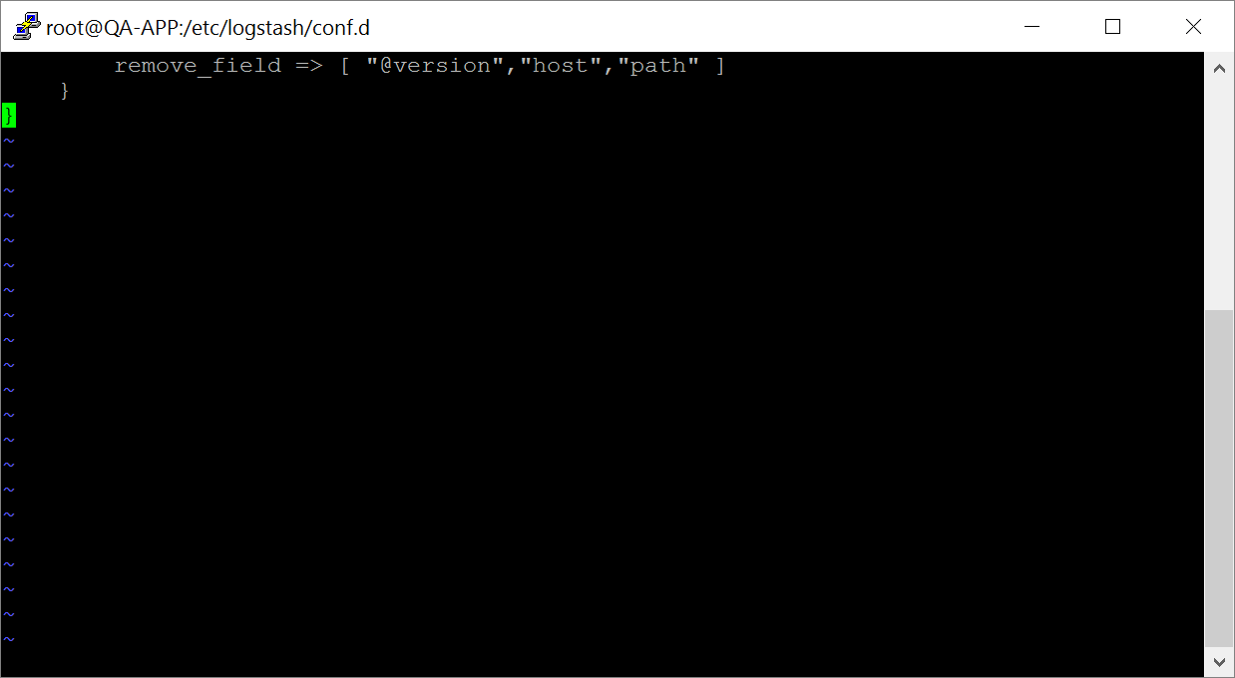

(After paste the above command, click Esc+:wq! To save the file and exit.)

- First file name: 30-elasticsearch-output.conf

perform the following command to create the file.

vi /etc/logstash/conf.d/30-elasticsearch-output.conf

Editor will open after perform the above command,
Then, We need to paste the following code in to that editor

(Note: in this below command, we have to change the Elasticsearch host IP address:port which is ElasticSearch-IP:9200 and replace with the existing elasticsearch IP and port number)
The Elasticsearch host IP with Port number changing will be 6 places.

output {
if [documentType] == "appointments"
{
if [action] == "delete"
{
elasticsearch {
hosts => ["10.10.47.35:9200"]
index => "findadoctor"
action => "delete"
document_id => "%{documentId}"
document_type => "%{documentType}"
parent => "%{parentId}"
}
stdout {}
}
else{
elasticsearch {
hosts => ["10.10.47.35:9200"]
index => "findadoctor"
doc_as_upsert => true
document_id => "%{documentId}"
document_type => "%{documentType}"
parent => "%{parentId}"
}
stdout {}
}
}
else if [documentType] == "doctor"
{
if [action] == "delete"
{
elasticsearch {
hosts => ["10.10.47.35:9200"]
index => "findadoctor"
action => "delete"
document_id => "%{addressDoctorId}"
document_type => "%{documentType}"
}
stdout {}
}else if [action] == "update"
{
if [update] == "availability"{
elasticsearch {
hosts => ["10.10.47.35:9200"]
index => "findadoctor"
document_id => "%{addressDoctorId}"
document_type => "%{documentType}"
}
}else{
elasticsearch {
hosts => ["10.10.47.35:9200"]
index => "findadoctor"
action => "update"
document_id => "%{addressDoctorId}"
document_type => "%{documentType}"
upsert => '{
"lName" : "%{lName}",
"taxonomy" : "%{taxonomy}",
"npi" : "%{npi}",
"isSubscribed" : "%{isSubscribed}",
"credentialText" : "%{credentialText}",
"gender" : "%{gender}",
"userId" : "%{userId}",
"languagesSpoken" : "%{languagesSpoken}",
"likes" : "%{likes}",
"fName" : "%{fName}",
"mName" : "%{mName}",
"insuranceIds" : "%{insuranceIds}",
"prefix" : "%{prefix}",
"boardCertificationsCode" : "%{boardCertificationsCode}",
"addressDoctorId" : "%{addressDoctorId}"
}'
}
}
}else
{
elasticsearch {
hosts => ["10.10.47.35:9200"]
index => "findadoctor"
doc_as_upsert => true
document_id => "%{addressDoctorId}"
document_type => "%{documentType}"
}
stdout {}
}
}
}

(After paste the above command, click Esc+:wq! To save the file and exit.)

